AI-POWERED SMART INSOLE FOR REAL-TIME GAIT MONITORING



By
MARYAM MALIK
48956

MOMINA ZAFAR
49544

RAFIA KANWAL
49553

Final Year Project Report

Department of Biomedical Engineering
Riphah International University, Pakistan

Spring 2026

 | Riphah International University  Pakistan

AI-POWERED SMART INSOLE FOR REAL-TIME GAIT MONITORING

A Thesis Presented to

Riphah International University, Pakistan

In partial fulfillment
Of the requirement for the degree of

B.S. Biomedical Engineering

By
MARYAM MALIK
48956

MOMINA ZAFAR
49544

RAFIA KANWAL
49553

Spring, 2026

Declaration
We, hereby, declare that this project, neither as a whole nor as a part thereof, has been copied from any source. It is further declared that we have developed this project and the accompanying report entirely based on our personal efforts made under the sincere guidance of our supervisor. No portion of the work presented in this report has been submitted in support of any other degree or qualification of this or any other University or Institute of Learning. If found, we shall stand responsible.
Signature: ______________
Name: Maryam Malik

Signature: ______________
Name: Momina Zafar

Signature: ______________
Name: Rafia Kanwal

Riphah International University, Pakistan
Spring 2026

Department of Electrical/Biomedical Engineering
Riphah International University, Pakistan

The project “AI-Powered Smart Insole For Real-Time Gait Monitoring”, presented by:

1 | Maryam Malik | 48956
2 | Momina Zafar | 49544
3 | Rafia Kanwal | 49553

under the supervision of their project advisor and approved by the project examination committee, has been accepted by the Riphah International University, Pakistan, in partial fulfillment of the requirements for the four-year degree of B.S. Biomedical Engineering.

Engr. Hamza Toor
Project Advisor

Dr. Faraz Akram
HOD
Department of Biomedical Engineering
Dedication
We dedicate this project to our beloved parents, whose love, prayers, sacrifices, and unwavering support have been the foundation of our success.
To the fathers who worked tirelessly and to the mothers who prayed and directed us to the right paths, this achievement is yours.
Maryam Malik dedicates this work to her beloved parents:
Mr. Aftab Ahmed and Mrs. Samina Aftab
Momina Zafar dedicates this work to her beloved parents:
Mr. Zafar Iqbal and Mrs. Rehana Zafar
Rafia Kanwal dedicates this work to her beloved parents:
Mr. Muhammad Saftain and Mrs. Makhtoom Akhter
Your guidance, encouragement, and unconditional love have brought us here today.

Acknowledgement
All praise and gratitude are due to Allah Almighty, the Most Gracious and Most Merciful, whose boundless blessings and guidance enabled us to complete this project successfully.
We would like to express our sincere gratitude to our project supervisor, Engr. Hamza Toor, for his invaluable guidance, continuous support, patience, and constructive feedback throughout the course of this research. His expertise, encouragement, and belief in our abilities have been instrumental in shaping this work from concept to completion.
We are deeply thankful to Dr. Faraz Akram, Head of the Department of Biomedical Engineering, for providing the necessary facilities, resources, and an encouraging academic environment that facilitated our research endeavors. His leadership and commitment to student development have been truly inspiring.
Our sincere appreciation extends to all the faculty members and laboratory staff of the Biomedical Engineering Department at Riphah International University, Pakistan, for their technical assistance, valuable suggestions, and moral support during various stages of this project. We would especially like to thank Sir Saif, our lab instructor and one of our professor Engr.Syed Uzair Iftikhar, our professor, for their dedicated help, practical guidance, and continuous support throughout the hardware development and testing phases of this project.
We are also grateful to our fellow classmates, particularly Bilal and Uzair Sajid, for their invaluable assistance, technical discussions, and moral support during challenging phases of the project.
We are profoundly grateful to our families for their unconditional love, patience, financial support, and unwavering encouragement. Their sacrifices and prayers have been the foundation of our academic journey, and without them, none of this would have been possible.
Finally, we would like to thank all the volunteers who participated in our testing sessions and provided valuable feedback for the improvement of our smart insole system.
Thank you all.
Maryam Malik (48956)
Momina Zafar (49544)
Rafia Kanwal (49553)

Abstract
Gait problems are common in people with musculoskeletal and rehabilitative conditions. Many commercial gait monitoring systems are expensive, not portable, or not suitable for use. This project aimed to address this gap by designing and developing a cost-smart insole system for real-time gait monitoring.
The proposed system consists of two insoles, one for each foot, with five force-sensitive resistors embedded in each insole. Each insole is connected to an ESP32 S3 microcontroller, powered using a 3.7V LiPo battery. The sensed plantar pressure data are transmitted wirelessly to an application via Bluetooth Low Energy. The mobile application displays live sensor values, plantar pressure distribution, center of pressure trajectory, left/right balance, step count, cadence, and other gait-related indicators.
The developed prototype successfully demonstrated bilateral plantar pressure acquisition and mobile-based visualization. The findings suggest that the proposed system is a portable platform for affordable gait monitoring and can be further extended for rehabilitation assessment, abnormal gait detection, and clinician-assisted decision support.

Keywords: Insole Gait Monitoring, Plantar Pressure, Force Sensitive Resistor, ESP32 S3, Bluetooth Low Energy, Wearable Biomedical Device, Mobile Health support.

TABLE OF CONTENTS

Chapter 1: Introduction . . . . . . . . . . . . . . . . . . . . . . . . . . . . . . . . . 14
1.1 Background and Context . . . . . . . . . . . . . . . . . . . . . . . . . . . . . . 14
1.2 Problem Statement . . . . . . . . . . . . . . . . . . . . . . . . . . . . . . . . 15
1.3 Contribution to Sustainable Development Goals (SDGs) . . . . . . . . . . . . . . . 16
1.4 Objectives and Research Questions . . . . . . . . . . . . . . . . . . . . . . . . 17
1.5 Scope and Methodology . . . . . . . . . . . . . . . . . . . . . . . . . . . . . . 18
1.6 Contribution to the Field . . . . . . . . . . . . . . . . . . . . . . . . . . . . 19
1.7 Thesis Structure . . . . . . . . . . . . . . . . . . . . . . . . . . . . . . . . . 20
1.8 Summary . . . . . . . . . . . . . . . . . . . . . . . . . . . . . . . . . . . . . 21
Chapter 2: Literature Survey . . . . . . . . . . . . . . . . . . . . . . . . . . . . . . . 23
2.1 Introduction . . . . . . . . . . . . . . . . . . . . . . . . . . . . . . . . . . . 23
2.2 Smart Insole Systems for Plantar Pressure Monitoring . . . . . . . . . . . . . . . 24
2.3 Sensor Technologies and Insole Fabrication Approaches . . . . . . . . . . . . . . 25
2.4 Wireless Communication, Real-Time Monitoring, and Mobile Integration . . . . . . . 26
2.5 Clinical and Rehabilitation Applications . . . . . . . . . . . . . . . . . . . . . 27
2.6 Machine Learning and Intelligent Gait Analysis . . . . . . . . . . . . . . . . . . 28
2.7 Sensor Layout, COP Estimation, and Minimal-Sensor Designs . . . . . . . . . . . . 29
2.8 Validation, Accuracy, and Practical Limitations in Existing Work . . . . . . . . . 29
2.9 Research Gap and Motivation for the Present Work . . . . . . . . . . . . . . . . . 30
2.10 Summary . . . . . . . . . . . . . . . . . . . . . . . . . . . . . . . . . . . . . 31
Chapter 3: Development ; Methodology . . . . . . . . . . . . . . . . . . . . . . . . . . . 33
3.1 Overview of Methodology . . . . . . . . . . . . . . . . . . . . . . . . . . . . . 33
3.2 System Architecture . . . . . . . . . . . . . . . . . . . . . . . . . . . . . . . 34
3.3 Hardware Design of the Smart Insoles . . . . . . . . . . . . . . . . . . . . . . . 35
3.3.1 Insole Sensor Configuration . . . . . . . . . . . . . . . . . . . . . . . . 35
3.3.2 Electrical Interfacing of Sensors . . . . . . . . . . . . . . . . . . . . . 35
3.3.3 Bilateral Wearable Node Design . . . . . . . . . . . . . . . . . . . . . . . 36
3.3.4 Power Supply and Charging Arrangement . . . . . . . . . . . . . . . . . . . 37
3.4 Sensor Placement Strategy . . . . . . . . . . . . . . . . . . . . . . . . . . . . 37
3.5 Embedded Firmware Methodology . . . . . . . . . . . . . . . . . . . . . . . . . . 38
3.6 Mobile Application Development . . . . . . . . . . . . . . . . . . . . . . . . . . 39
3.7 Calibration Methodology . . . . . . . . . . . . . . . . . . . . . . . . . . . . . 40
3.7.1 Zero Calibration . . . . . . . . . . . . . . . . . . . . . . . . . . . . . . 40
3.7.2 Span Calibration . . . . . . . . . . . . . . . . . . . . . . . . . . . . . . 41
3.8 Data Acquisition and Processing Workflow . . . . . . . . . . . . . . . . . . . . . 42
3.9 Computation of Gait-Related Parameters . . . . . . . . . . . . . . . . . . . . . . 42
3.9.1 Foot-Wise Pressure Totals . . . . . . . . . . . . . . . . . . . . . . . . . 42
3.9.2 Bilateral Balance . . . . . . . . . . . . . . . . . . . . . . . . . . . . . 43
3.9.3 Symmetry Index . . . . . . . . . . . . . . . . . . . . . . . . . . . . . . . 43
3.9.4 Center of Pressure (COP) . . . . . . . . . . . . . . . . . . . . . . . . . . 43
3.9.5 Step Count, Cadence, and Estimated Speed . . . . . . . . . . . . . . . . . . 43
3.10 Wearable Assembly and Testing Procedure . . . . . . . . . . . . . . . . . . . . . 44
3.11 Scope and Limitations of the Implemented Methodology . . . . . . . . . . . . . . 44
Chapter 4: Implementation and Results . . . . . . . . . . . . . . . . . . . . . . . . . . 46
4.1 Introduction . . . . . . . . . . . . . . . . . . . . . . . . . . . . . . . . . . 46
4.2 Hardware Implementation . . . . . . . . . . . . . . . . . . . . . . . . . . . . . 46
4.2.1 Bilateral Smart Insole Prototype . . . . . . . . . . . . . . . . . . . . . 46
4.2.2 Sensor Interfacing Circuit . . . . . . . . . . . . . . . . . . . . . . . . 47
4.2.3 Wearable Assembly . . . . . . . . . . . . . . . . . . . . . . . . . . . . . 48
4.3 Embedded System Implementation . . . . . . . . . . . . . . . . . . . . . . . . . 49
4.3.1 ESP32-S3 Firmware . . . . . . . . . . . . . . . . . . . . . . . . . . . . . 49
4.3.2 Calibration Support in Firmware . . . . . . . . . . . . . . . . . . . . . . 50
4.3.3 BLE Data Transmission . . . . . . . . . . . . . . . . . . . . . . . . . . . 50
4.4 Mobile Application Implementation . . . . . . . . . . . . . . . . . . . . . . . . 51
4.4.1 Application Architecture . . . . . . . . . . . . . . . . . . . . . . . . . 51
4.4.2 Real-Time Monitoring Interface . . . . . . . . . . . . . . . . . . . . . . 52
4.4.3 Pressure Map Visualization . . . . . . . . . . . . . . . . . . . . . . . . 53
4.4.4 COP Trajectory Visualization . . . . . . . . . . . . . . . . . . . . . . . 53
4.4.5 Clinical Metrics and Session Recording . . . . . . . . . . . . . . . . . . 55
4.5 Calibration Implementation and Results . . . . . . . . . . . . . . . . . . . . . 56
4.5.1 Calibration Page . . . . . . . . . . . . . . . . . . . . . . . . . . . . . 56
4.5.2 Zero Calibration Behavior . . . . . . . . . . . . . . . . . . . . . . . . . 57
4.5.3 Span Calibration Behavior . . . . . . . . . . . . . . . . . . . . . . . . . 57
4.5.4 Calibration Summary . . . . . . . . . . . . . . . . . . . . . . . . . . . . 57
4.6 Preliminary Functional Testing . . . . . . . . . . . . . . . . . . . . . . . . . 58
4.6.1 Connection and Streaming Verification . . . . . . . . . . . . . . . . . . . 58
4.6.2 Live Pressure Response . . . . . . . . . . . . . . . . . . . . . . . . . . 58
4.6.3 Bilateral Balance Behavior . . . . . . . . . . . . . . . . . . . . . . . . 59
4.6.4 COP Response . . . . . . . . . . . . . . . . . . . . . . . . . . . . . . . 59
4.6.5 Gait-Related Parameter Behavior . . . . . . . . . . . . . . . . . . . . . . 59
4.7 Discussion of Prototype Performance . . . . . . . . . . . . . . . . . . . . . . . 61
4.8 Summary . . . . . . . . . . . . . . . . . . . . . . . . . . . . . . . . . . . . . 62
Chapter 5: Discussion and Conclusion . . . . . . . . . . . . . . . . . . . . . . . . . . 63
5.1 Further Opportunities . . . . . . . . . . . . . . . . . . . . . . . . . . . . . . 63
5.2 Conclusion . . . . . . . . . . . . . . . . . . . . . . . . . . . . . . . . . . . 64
Chapter 6: References . . . . . . . . . . . . . . . . . . . . . . . . . . . . . . . . . . 66

List of figures

Figure 1.2.1: Necessity of Project: Market Demand &amp; Clinical Applications . . . . . . . . . . 16
Figure 3.1: Complete System Architecture and Data Processing Chain . . . . . . . . . . . . . . 34
Figure 3.4: Flutter Mobile Application Navigational Architecture and Tab Layout . . . . . . . 39
Figure 3.7.2 : Calibration of FSR's……42
Figure 4.1: Final hardware prototype of left and right smart insoles with electronics assembly . 48
Figure 4.2: Circuit schematic of one insole sensing channel arrangement . . . . . . . . . . . 49
Figure 4.3: Developed wearable smart insole hardware assembly prior to final footwear integration . . 50
Figure 4.4: Physical wired implementation of the single insole node hardware showcasing the ESP32-S3. 51
Figure 4.5: Mobile application initialization interface displaying the patient demographic profile . 53
Figure 4.6: Main real-time monitoring and recording interface dashboard . . . . . . . . . . . 54
Figure 4.7: Pressure map screen showing left and right foot sensor values . . . . . . . . . . 55
Figure 4.8: Center of Pressure (COP) trajectory plotting graph capturing real-time postural sway . 56
Figure 4.9: Post-session review screen displaying calculated spatiotemporal metrics . . . . . 56
Figure 4.10: Post-session review screen displaying computed spatiotemporal clinical metrics .57
Figure 4.11: Calibration page with global and per-sensor controls . . . . . . . . . . . . . . 58

List of tables
Table 4.1: Final Calibrated Zero Offset (V_zero) and Span Multiplier (S_m) per Sensor Channel . 60
Table 4.2: Real-Time Data Throughput and Packet Loss Rate over BLE Streaming . . . . . . . . 62

List of abbreviations
1G | First generation
2D | Two dimensional
3-D | Three dimensional
4G | Fourth generation
ABW | Absolute bandwidth
API | Application programming interface
CAD | Computer-aided design
DAA | Detect and Avoid
dB | Decibels
ECC | Electronic communications committee
ETRI | Electronics and Telecommunications Research Institute
FBW | Fractional bandwidth
FCC | Federal Communications Commission
FDTD | Finite difference time domain
FEM | Finite element method
FIT | Finite integration technique
FNBW | First null beam width
GA | Genetic algorithm
GHz | Giga hertz
HPBW | Half power beamwidth
IDA | Infocomm Development Authority
ISM | Industrial Scientific and Medicine
ITU | International Telecommunication Union
MATLAB | Matrix laboratory
MIC | Ministry of Internal Affairs and Communications
mm | Millimeter
MoM | Method of Moments
PCB | Printed circuit board
SNR | Signal-to-noise ratio
UWB | Ultra-wideband
VSWR | Voltage standing wave ratio
Wi-Fi | Wireless fidelity
WLAN | Wireless local area network
WPAN | Wireless personal area network

CHAPTER ONE

1. Introduction

1.1 Background and Context

An important indicator of physical mobility, musculoskeletal health, neurological function, rehabilitation progress, and fall risk. Variations in plantar pressure distribution, step symmetry, and heel-to-toe transition can reveal abnormalities associated with injury: aging, stroke, diabetic foot complications, and other gait-related disorders. In clinical practice, gait assessment is commonly performed using observational analyses or specialized laboratory-grade systems. Although such systems can provide valuable information, they are often expensive, bulky, non-portable, and impractical for continuous daily monitoring outside controlled environments.
Recent developments in wearable electronics, embedded sensing, wireless communication, and mobile health technologies have enabled the design of compact and low-cost systems to provide real-time physiological and biomechanical monitoring. Smart insoles have emerged as a promising solution because they can capture plantar pressure information directly from the foot during standing and walking without interfering significantly with natural movement. Compared with camera-based or laboratory-based gait analysis systems, instrumented insoles offer portability, lower cost, ease of use, and long-duration ambulatory monitoring. Within this context, the present project focuses on the development of a wearable smart insole system for real-time gait monitoring.
The system uses pressure sensors embedded inside left and right insoles, individual ESP32/S3-based wireless sensing units, and a mobile application for live data visualization and analysis. The project title and proposed direction emphasize a low-cost smart insole architecture for gait monitoring that includes pressure sensing, Bluetooth data transmission, mobile application support, and gait-related interpretation.

1.2 Problem Statement

Existing gait monitoring systems used in rehabilitation, clinical, and mobility assessment are often costly, location-dependent, and difficult to deploy in everyday settings. Many available solutions require specialized laboratories, external motion capture systems, or high-cost plantar pressure platforms, which limit their accessibility for continuous monitoring and routine rehabilitation support.

The project presentation also identifies the specific gap by highlighting that the current gait monitoring systems are expensive and non-portable, and that a low-cost, real-time, wearable solution is lacking. This creates a practical need for an affordable, portable, and real-time gait monitoring system capable of acquiring bilateral plantar pressure information and presenting clinically meaningful indicators through a user-friendly interface. The absence of such systems reduces the ability to perform frequent gait assessment, track rehabilitation progress objectively, and identify asymmetry or abnormal loading patterns in daily life.

Figure 1.2.1 illustrates how the project fits market demand and practical healthcare needs.

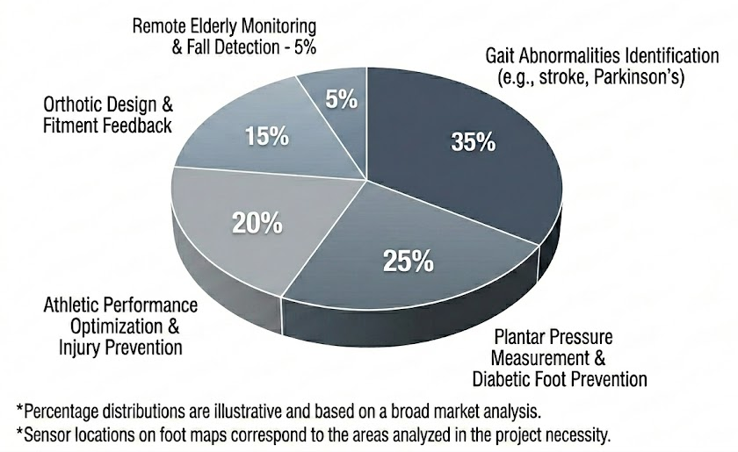
Figure 1.2. 1 Necessity of Project: Market Demand & Clinical Applications

1.3 Contribution to Sustainable Development Goals (SDGs)
The developed Smart Insole System is intended to provide real-time gait-related information that can assist in rehabilitation monitoring, mobility evaluation, and early identification of pressure imbalance or abnormal walking patterns. This is directly consistent with the project's stated focus on improving health outcomes and quality of life. The project also aligns secondarily with industry, innovation, and infrastructure, using embedded sensing, wireless communication, and mobile health technology to develop an indigenous biomedical wearable system.
In addition, it has relevance to: Ten Sudanese pounds: reduced inequalities, as a low-cost portable monitoring platform can improve access to gait assessment tools for individuals who may not have access to expensive clinical infrastructure. These SDG links are also reflected in the project's self-assessment slide. In the context of Pakistan, the significance of this contribution lies in the development of practical and affordable health care technologies that can be adopted in rehabilitation settings, academic prototyping, and future community-level screening applications. A locally developed Smart Insole platform can reduce cost barriers and encourage further innovation in wearable biomedical systems.

1.4 Objectives and Research Questions

The project presentation states that the system aims to develop a low-cost Smart Insole for rehabilitation-oriented gait monitoring and to improve rehabilitation outcomes and patient safety through real-time sensing and mobile feedback. Based on the implemented scope of this work, the objectives of this thesis are as follows:

To design and develop a bilateral Smart Insole system using pressure sensors embedded in the left and right insoles

To interface each insole with an ESP32-S3 microcontroller for real-time data acquisition and Bluetooth Low Energy transmission.

To develop a mobile application capable of displaying live plantar pressure data from both feet simultaneously.

To estimate gait-related parameters such as plantar pressure distribution, left-right balance, step count, cadence, and center pressure trajectory.

To develop a wearable and portable hardware configuration suitable for on-body testing using ankle-mounted electronics and rechargeable battery operation.

To establish a calibration and testing workflow for practical use of the developed prototype.

To achieve these objectives, the following research questions are addressed:

Can a low-cost bilateral smart insole system be developed using force-sensitive resistors and ESP32-S3 modules for real-time gait monitoring?

Can plantar pressure data from both feet be transmitted wirelessly and visualized effectively on a mobile application?

Can the developed system provide useful gait-related indicators such as pressure distribution, symmetry, step count, and COP trajectory in real time?

Is the proposed hardware architecture suitable for wearable deployment and practical testing?

To what extent can the developed prototype serve as a foundation for future rehabilitation and clinical gait analysis applications?

1.5 Scope and Methodology
The scope of this thesis is limited to the design, implementation, and preliminary testing of a wearable bilateral smart insole system based on plantar pressure sensing. The developed prototype consists of two insoles, one for the left foot and one for the right foot, each containing five force-sensitive resistor sensors. Four FSR-402 sensors and one FSR-406 sensor are integrated within each insole to capture plantar loading from key foot regions. Each sensor is interfaced through a resistor-based circuit, where the FSR-402 sensors are connected through 3.3 kOhm resistors, and the FSR-406 sensor is connected through a 150 ohms resistor. Each insole is connected to its own ESP32S3 microcontroller for independent sensing and wireless transmission.
Power is supplied through a 3.7V LiPo battery, while charging is supported through a TP4056 charging module. A physical switch is included for on-off control. The hardware is worn using an ankle pouch attached with Velcro to provide portable testing without restricting foot movement.
The methodology adopted in this work includes the following stages:
- Selection and placement of plantar pressure sensors at functionally relevant regions of the foot.
- Design of the sensor interfacing circuit and integration with ESP32-S3 microcontrollers.
- Development of embedded firmware for sensor acquisition, filtering, calibration, and BLE data transmission.
- Development of a Flutter-based mobile application for receiving and displaying live data from both insoles.
- Implementation of software features for real-time visualization, calibration, recording, and gait-related parameter estimation.
- Wearable assembly and practical on-body testing of the prototype.
The present work focuses on system development and prototype validation.. Instead, it serves as a functional and scalable platform for low-cost real-time gait monitoring.

1.6 Contribution to the Field
The principal contribution of this thesis is the development of a low-cost, wearable, and mobile-enabled smart insole platform for bilateral gait monitoring. Unlike fixed-gait laboratories or expensive plantar pressure systems, the proposed solution emphasizes portability, affordability, and practical implementation using commercially available components.

This work contributes to the field in the following ways:
- It presents a dual insole embedded hardware architecture using independent ESP32S3 sensing nodes for left- and right-plantar pressure acquisition.
- It integrates multiple FSR sensors within each insole to capture major gait phases, from heel contact to toe off, in a wearable format.
- It demonstrates a real-time BLE-based mobile application workflow for data display, calibration, and monitoring.
- It provides a prototype framework for estimating clinically relevant gait-related indicators such as COP trajectory, bilateral balance, and step-related measures.
- It establishes a foundation for future extensions, including improved clinical metrics, rehabilitation analytics, machine learning-based gait classification, and remote monitoring features.
From a broader perspective, the system offers a practical pathway toward affordable digital mobility assessment tools in biomedical engineering, especially in settings where access to expensive gait laboratories is limited.

1.7 Thesis Structure
This thesis is organized into five main chapters.
- “Chapter 1” presents the introduction, including the project background, problem statement, SDG relevance, objectives, research questions, scope, contribution, and chapter organization.
- “ Chapter 2” presents a literature survey. It reviews existing work on plantar pressure sensing, wearable smart implants, gait monitoring systems, sensor technologies, wireless biomedical devices, and mobile health applications. It also identifies the research gap addressed by this thesis.
- “Chapter 3” describes methodology and system design. It explains the hardware architecture, sensor selection circuit configuration, ESP32S3-based embedded system power and charging arrangement, insole fabrication, calibration procedure, mobile application development, and parameter estimation strategy
- “Chapter 4” presents the implementation and results detailing the physical prototyping of both the left and right insoles, the deployment of the ESP32S3 firmware, and the creation of the Flutter mobile application interface. This chapter highlights the sensor calibration workflows, verification of real-time bilateral data streaming over Bluetooth low energy, and initial validation of gate indicators, including center of pressure, COP trajectories, balance, and step monitoring.
- “Chapter 5” provides discussion and conclusions. It interprets the development system in relation to the project objectives, discusses strengths and limitations, and proposes future improvements and extensions for clinical and rehabilitation use.
The thesis concludes with a list of references formatted in IEE style as required by the thesis template.
1.8 Summary
This chapter introduced the motivation and context of the smart internet insole project and established the need for an affordable, wearable gait-monitoring system. The problems of high cost and non-portability of conventional gait analysis systems were identified, and the proposed bilateral smart insole solution was presented as a practical alternative. The objectives, research questions, project scope, SDG relevance, and expected contributions were outlined in a structured manner.

The chapter also summarized the organization of the thesis and positioned the current work as a prototype platform for real-time plantar pressure and gait monitoring. The next chapter presents the literature survey and reviews prior work relevant to smart insoles, plantar pressure sensing, and wearable gait analysis systems.

.

CHAPTER TWO

2 LITERATURE SURVEY
2.1 Introduction
Wearable gait monitoring has become an important area of research in biomedical engineering because gait is strongly associated with balance, mobility, rehabilitation progress, neurological impairment, diabetic foot risk, and fall prevention. Conventional gait assessment methods, including laboratory motion capture systems, force plates, and clinical pressure platforms, can provide accurate measurements but are often expensive, non-portable, and limited to controlled environments. In contrast, smart insole systems offer the possibility of real-time plantar pressure sensing in a low-cost, compact, and wearable form factor that can support daily monitoring and field deployment.
The literature on smart insoles has expanded significantly in recent years, with research focusing on sensor materials, insole architecture, wireless communication, gait feature extraction, center of pressure estimation, diabetic foot applications, rehabilitation support, and machine learning-based classification [1]. These studies show that smart insoles are increasingly being developed not only for plantar pressure measurement but also for broader healthcare applications such as gait event detection, pathology screening, pressure offloading, and real-time decision support.
The purpose of this literature survey is to review the major developments in wearable smart insole systems and to identify the most relevant design directions, technical trade-offs, and research gaps for the present project. The review focuses on pressure-sensing insoles, wireless data acquisition, mobile integration, gait parameter estimation, intelligent classification, and clinical applicability. Particular attention is given to low-cost and portable designs, since the central motivation of the present project is to develop an affordable bilateral smart insole system for real-time gait monitoring.
2.2 Smart Insole Systems for Plantar Pressure Monitoring
A major portion of the literature focuses on smart insoles as wearable platforms for plantar pressure measurement during standing and walking. Recent studies have demonstrated both high-end and low-cost approaches to pressure monitoring, ranging from dense sensor matrices to simplified layouts with a limited number of sensing nodes [1], [2], [3], [4], [5], [6], [7]. These works confirm that plantar pressure measurement using insoles can provide useful information related to gait phases, foot loading, step progression, and asymmetry.
Several studies emphasize the advantage of wireless and mobile-compatible insole systems for real-time monitoring in non-laboratory environments [1], [8], [9], [5], [6], [7]. Such systems are particularly attractive because they can be used during natural locomotion instead of restricting assessment to specialized biomechanics laboratories. In this context, wearable smart insoles serve as a practical bridge between clinical-grade measurement and everyday monitoring.
At the same time, the literature reveals an important trade-off between spatial resolution and system complexity. High-resolution systems using dense arrays or tactile matrices provide detailed pressure maps and better local peak detection [10], [4], [10], but they involve higher cost, more complex data handling, larger power requirements, and more challenging fabrication. In contrast, simplified insole systems with fewer sensing points are more practical for portable implementation, although they may sacrifice local resolution or dynamic accuracy [11], [5], [12]. This trade-off is directly relevant to the present project, which targets a low-cost wearable architecture rather than a dense laboratory-grade pressure matrix.
2.3 Sensor Technologies and Insole Fabrication Approaches
The reviewed literature shows substantial diversity in the types of sensors used for plantar pressure measurement. Capacitive sensing has been widely investigated because of its sensitivity, repeatability, and suitability for flexible insole fabrication [13], [2], [14]. Capacitive designs have also been implemented using textile-based materials and 3D-printed structures, which support low-weight and customizable fabrication [2], [14]. However, these designs may suffer from fabrication complexity, hysteresis, long-term stability issues, or wear-related degradation.
Self-powered sensing technologies, especially triboelectric nanogenerator-based systems, have also gained significant attention [1], [10]. These systems reduce the dependence on external power sources and offer high-resolution pressure mapping, which is attractive for future next-generation wearable insoles. Nevertheless, the literature indicates that these systems still face challenges in output variability, integration complexity, manufacturing difficulty, and the need for broader clinical testing [1], [10].
Other studies have explored piezoresistive, strain-based, photoelectric, and modular sensor arrangements [8], [15], [16], [5]. These approaches are generally attractive for low-cost designs and practical prototyping, although they may provide lower spatial resolution than dense capacitive or tactile arrays. The literature suggests that for affordable wearable applications, simpler architectures with moderate sensor count remain highly relevant, particularly when the aim is gait monitoring rather than high-resolution plantar imaging.
This observation supports the design choice of the present work, which uses a small set of strategically placed sensors on each insole rather than a dense sensor matrix. Such an approach is more feasible for battery-powered, BLE-enabled, bilateral wearable monitoring.
2.4 Wireless Communication, Real-Time Monitoring, and Mobile Integration
Real-time data communication is a recurring design requirement in smart insole research. Many reported systems emphasize wireless transmission to smartphones, portable receivers, or remote monitoring platforms [1], [8], [9], [5], [6], [7]. Wireless systems are preferred because they improve user mobility, reduce cable-related discomfort, and support real-world deployment outside the lab.
Several studies combine wireless pressure sensing with low-power operation, embedded processing, and remote monitoring capability [8], [6], [7]. This is especially important for rehabilitation-oriented systems, where clinicians may benefit from live or recorded gait information collected over repeated sessions. Mobile integration also improves usability by enabling live visualization, data logging, and feedback on ordinary handheld devices rather than dedicated workstations.
The literature also highlights the practical value of field-validated portable insoles [9], [7]. Validation-oriented studies show that portable insoles can support clinically useful estimates of gait-related variables when carefully calibrated and appropriately configured, although device-to-device variability and sensor placement remain important concerns [9], [7]. These findings reinforce the need for reliable wireless communication, stable calibration, and repeatable data capture in any practical insole design.

2.5 Clinical and Rehabilitation Applications
A significant portion of the literature focuses on clinical applications, especially diabetic foot monitoring, pressure offloading, gait rehabilitation, and pathology-specific detection [17], [18], [19], [7], [20], [21], [22], [23], [24]. In diabetic foot care, plantar pressure monitoring is particularly important because abnormal peak loading and repetitive stress are associated with ulcer formation and recurrence. Studies on intelligent insoles, offloading systems, and pressure-reducing insole designs show that wearable foot monitoring can support prevention strategies and potentially improve patient outcomes [18], [7], [20], [22], [24].
Some works demonstrate direct clinical utility. For example, instrumented insoles with alerting or intervention capability have been shown to reduce diabetic foot ulcer recurrence or support active pressure offloading [18], [7]. Similarly, modular and customizable insole designs have been investigated to address peak plantar pressures in high-risk users [20]. These studies suggest that smart insoles can move beyond passive sensing into therapeutic or preventive applications.
Neurological applications are also emerging. In particular, pressure-insoles combined with temporal deep learning methods have been used for freezing-of-gait detection in Parkinson’s disease [19]. This shows that plantar pressure information alone may contain meaningful temporal signatures for pathology-specific gait abnormalities. Although such advanced applications require large and well-annotated datasets, they demonstrate the broader clinical value of wearable foot-pressure systems.
Overall, the literature confirms that smart insoles are highly relevant to rehabilitation, chronic disease management, mobility assessment, and remote care. However, many systems remain specialized, expensive, or insufficiently validated across different user populations.

2.6 Machine Learning and Intelligent Gait Analysis
Machine learning has become increasingly important in smart insole research, particularly for classification, event detection, and recognition of abnormal gait patterns. Several studies have employed traditional machine learning approaches such as support vector machines, random forests, AdaBoost, and comparative classifier frameworks to analyze plantar pressure data [17], [23]. These approaches have shown that pressure-based features can be useful for differentiating healthy and pathological gait, including diabetic foot-related patterns [17], [23].
More recent work has moved toward deep learning-based insole intelligence. Convolutional neural networks and temporal convolutional networks have been used for multifunctional foot-healthcare analysis, gait recognition, and freezing-of-gait detection [13], [19], [25]. Dense sensor arrays and multimodal pressure-plus-IMU platforms have improved classification capability, particularly when high spatial resolution is available [13], [4], [25].
Despite these advances, the literature also reveals consistent limitations. Machine learning performance depends heavily on data quantity, subject diversity, sensor repeatability, and robust calibration [13], [17], [19], [25], [23]. Many studies remain limited by small datasets, early-stage prototypes, or narrow clinical cohorts. Therefore, while intelligent analysis is promising, foundational issues such as stable sensing, portable operation, and reliable feature generation remain essential.
For the present project, this is an important observation. Before advanced AI-based classification can become reliable, the underlying smart insole must provide consistent bilateral pressure acquisition, practical wearability, and meaningful real-time indicators such as balance, symmetry, gait phase transitions, and COP behavior.

2.7 Sensor Layout, COP Estimation, and Minimal-Sensor Designs
An important theme in the literature concerns how many sensors are required and where they should be placed. Studies on simplified insole layouts show that acceptable COP and gait estimates can be obtained with reduced sensor counts, provided that the sensor placement is biomechanically informed [11], [26]. These studies are particularly relevant for low-cost wearable designs, where fewer sensors reduce hardware cost, wiring complexity, data volume, and power consumption.
At the same time, the literature makes clear that simplifying the sensor layout affects estimation accuracy, especially during more dynamic activities such as faster walking or running [11], [26]. High-resolution matrices naturally provide superior local detail and more robust spatial pressure reconstruction [10], [4], but simplified layouts are still attractive when the goal is portable gait monitoring rather than full plantar imaging.
This trade-off strongly supports a design strategy based on carefully selected anatomical pressure points rather than dense arrays. The sensor placement rationale shown in the project’s design presentation—covering heel, medial region, midfoot, forefoot, and toe—corresponds well to the major biomechanical stages of gait from initial contact to toe-off. Such a layout is suitable for capturing essential gait transitions, bilateral loading, and approximate COP behavior while maintaining a practical wearable structure.
2.8 Validation, Accuracy, and Practical Limitations in Existing Work
Although many smart insole studies report promising results, the literature consistently identifies several recurring limitations. First, long-term durability remains a concern, especially for textile, capacitive, and novel-material sensor systems that experience repeated bending, compression, and environmental exposure [2],[14]. Second, many prototypes are validated on small cohorts or healthy adults only, which limits confidence in pathological or rehabilitation populations [16][27], [19], [26], [7].
Third, calibration and device-to-device variability remain important technical barriers. Even when portable insoles are field-capable, their performance can depend strongly on sensor arrangement, calibration method, sampling conditions, and subject-specific behavior [9], [11], [21], [7]. Fourth, high-resolution or self-powered systems often introduce additional complexity in fabrication, signal processing, or power management [1], [13], [10], [4] .
These limitations show that there is still a strong need for practical smart insole systems that balance affordability, wearability, calibration feasibility, wireless communication, and clinically interpretable output. The present project is positioned within this gap by prioritizing a low-cost and portable bilateral system with real-time mobile monitoring rather than a highly specialized or high-complexity research prototype.
2.9 Research Gap and Motivation for the Present Work
The reviewed studies collectively demonstrate that smart insoles are technically feasible and clinically promising; however, several gaps remain. High-resolution and advanced AI-driven systems often increase fabrication complexity, power demands, and cost [1], [13], [10], [4], [25]. Clinically validated systems, although useful, may still be relatively expensive or targeted toward specific use cases such as diabetic foot prevention rather than general-purpose gait monitoring [18], [7], [20], [22]. On the other hand, low-cost prototypes often simplify the sensing architecture but may not fully integrate bilateral real-time monitoring, mobile application support, calibration workflow, and practical wearable deployment [8], [15], [5], [26].

Therefore, a clear gap exists for a compact and economical smart insole platform that combines bilateral plantar pressure sensing, wireless BLE transmission, mobile-based visualization, and basic gait intelligence in a practically wearable configuration. The current project addresses this need by developing left and right insoles with strategically placed pressure sensors, independent ESP32-S3 sensing nodes, rechargeable battery-powered operation, BLE-based mobile data transmission, and software support for plantar pressure display, COP trajectory, step monitoring, balance analysis, and gait-related interpretation. This system is intended as a practical engineering prototype that can later be extended toward more advanced rehabilitation and clinical monitoring applications. The overall project direction presented by the team also emphasizes low-cost rehabilitation monitoring, real-time feedback, and gait intelligence, which is consistent with the gap identified in the literature.
2.10 Summary
This chapter reviewed the literature relevant to wearable smart insoles for gait and plantar pressure monitoring. The review showed that recent research spans sensor technologies such as capacitive, piezoresistive, textile, photoelectric, and self-powered architectures, as well as wireless platforms, mobile-compatible systems, machine learning approaches, and clinical applications. Dense sensor matrices offer high spatial detail but increase complexity, whereas simplified sensor layouts provide a more feasible pathway for low-cost wearable implementation. The literature also highlighted the importance of calibration, wireless communication, mobile integration, and clinically meaningful output such as COP, balance, and abnormal gait detection.
Despite significant progress, existing solutions still exhibit limitations related to cost, complexity, long-term durability, validation scope, and calibration stability. These gaps justify the development of a practical low-cost bilateral smart insole system capable of real-time gait monitoring and mobile-based analysis. The next chapter presents the methodology adopted for the design and implementation of the proposed system, including hardware architecture, sensor interfacing, embedded acquisition, wireless communication, mobile application development, and calibration strategy.

CHAPTER THREE
3 DEVELOPMENTS
3.1 Overview of Methodology
This chapter presents the methodology used to design and implement the proposed Smart Insole system for real-time gait monitoring. The developed system was conceived as a low-cost wearable biomedical platform capable of acquiring plantar pressure data from both feet, wirelessly transmitting the data, and presenting gait-related information through a mobile application.
The overall project direction emphasized pressure sensor integration, ESP32-S3-based wireless communication, real-time Bluetooth data transmission, mobile monitoring, and the generation of gait-related insights for rehabilitation-oriented use. The complete methodology consisted of the following stages:
Selection of sensing locations on the foot development of left and right insole hardware design of the sensor interfacing and power circuitry integration of ESP32-S3 modules for independent bilateral acquisition firmware development for signal acquisition, position, and transmission, mobile application development for live visualization and analysis, calibration of the force sensitive resistors, and prototype-level wearable testing. Although the broader project concept referred to AI-powered gait analysis, the implemented prototype in this thesis focused on real-time sensing, calibration, pressure visualization, center of pressure estimation, and rule-based gait-related parameter extraction.
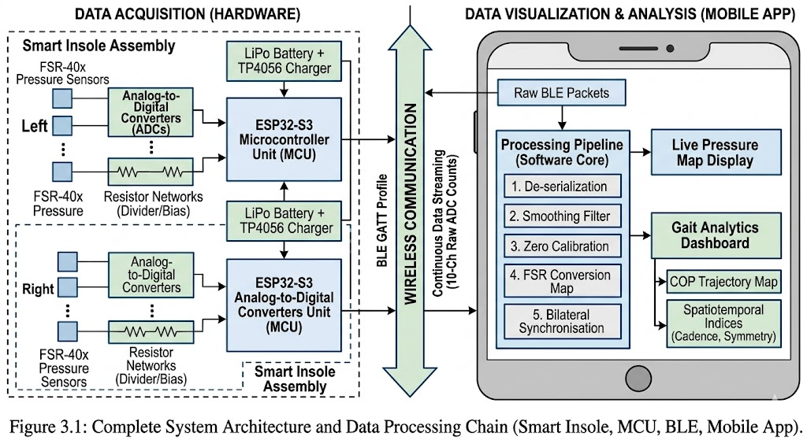
Figure 3.1 Complete System Architecture and Data Processing Chain(smart Insole, MCU, BLE, Mobile App)

3.2 System Architecture
The developed smart insole system consisted of two separate insoles: One for the left foot and one for the right foot. Each insole operates independently with its own sensing circuit, microcontroller, and power arrangement. The two sensing units transmitted their data simultaneously to a mobile application through Bluetooth Low Energy. This bilateral architecture was selected to allow independent left and right plantar pressure acquisition and to support parameters such as balance, symmetry, and phase-wise gait interpretation.
The project has the system as a bilateral platform with five pressure sensors per foot, continuous planter pressure monitoring, independent left and right analysis, and wireless BLE transmission to a mobile application. At the system level, the processing chain can be summarized as follows. Plantar pressure is sensed through force-sensitive resistors embedded in each insole. Analog sensor outputs are acquired by an ESP32-S3 microcontroller. Raw signals are filtered and calibrated in the embedded firmware. The processed sensor values are transmitted wirelessly through BLE. The flutter-based mobile application receives data streams from both insoles. The system displays live sensor values, pressure distribution, center of pressure trajectory, bilateral balance, and additional gait-related indicators. This architecture was selected to ensure modularity, ease of troubleshooting, and practical wearable integration.

3.3 Hardware Design of the Smart Insoles
3.3.1 Insole Sensor Configuration
Each insole contained a total of five force-sensitive resistor sensors that were FSR 402 sensors, and one was an FSR 406 sensor. The selection of five sensors per foot was based on the need to capture the major plantar loading regions relevant to gait while maintaining a compact, low-cost, and low-complexity design.
Instead of using a high-density pressure matrix, a limited number of strategically positioned sensors were employed so that the prototype could remain practical for wearable implementation to capture the main gait bases from heel strike to toe off.
The project design presentation identifies the functional importance of the heel, medial region, midfoot, forefoot, metatarsal region, and toe region for pressure transfer and gait transition. In particular, the heel was associated with initial contact and impact force. The medial region with weight transfer balance and arch stability. The midfoot overpronation of supination-related behavior. The forefoot metatarsal region with push-off force. And the toe region with a final toe off phase and cadence-related behavior.
3.3.2 Electrical Interfacing of Sensors
The pressure sensors were interfaced using resistor-based analog sensing circuits. One terminal of each sensor was connected to the supply voltage, while the second terminal was connected to the ESP32-S3's own ADC input through a fixed resistor for the four FSR402 sensors; a resistor value of 3.3kohm was used. For the FSR406 sensor, a resistor value of 150ohms was used. This arrangement formed a voltage divider-based sensing configuration, in which the resistance variation of the FSR under applied load produced a corresponding analog voltage at the microcontroller input.
The use of different resistor values for the FSR402 and FSR406 elements was motivated by the differing electrical characteristics and expected operating range of the sensors. The selected resistor network was aimed at producing measurable voltage variation within the ADC input range of the ESP32-S3 while preserving sufficient sensitivity for plantar loading.

3.3.3 Bilateral Wearable Node Design
Each foot uses an independent ESP32-S3 module. This decision provided several advantages for amplified routing and signal acquisition by keeping each insole self-contained. Second, it enabled bilateral monitoring without long wiring between feet. Third, it allowed each foot to be treated as an independent sensing node, while still supporting synchronized visualization in the mobile application. The complete wearable unit for each foot included:
- The insole with embedded pressure sensors
- The signal interfacing circuit
- The ESP32-S3 microcontroller
- MT3608 Boost Power Supply Converter
- LiPo battery 3.7 Volt
- A TP4056 charging module
- An on/off switch
The electronics were housed externally using an ankle pouch attached through velcro during testing. This approach improved practical wearability and protected the electronics while keeping the insole region primarily occupied by the sensors.

3.3.4 Power Supply and Charging Arrangement
Power for each insole load was provided using a 3.7-volt LiPo battery. Charging was implemented through a TP4056 charging module. The battery positive terminal was connected to B+ of the TP4056 module, and the battery negative terminal was connected to B-. The out T+ terminal of the charging module was connected to the VIN+ of MT3608, and the out T- terminal of the charging module was connected to the VIN- of MT3608. The VOUT- of MT3608 is connected to ground, and VOUT+ is connected to the positive of the switch, and the negative of the switch is connected to ground.
This arrangement enabled portable battery-powered operation, rechargeable use, and manual control of device activation. The inclusion of local power on each foot made the bilateral architecture independent and suitable for untethered testing.

3.4 Sensor Placement Strategy
Sensor placement can be used in any plantar pressure monitoring system. The quality of gait interpretation depends strongly on whether the sensing locations capture meaningful bio-mechanical events. In this project, five sensing positions per foot were selected to represent the most functionally relevant loading regions during the gate cycle.
The placement strategy followed a region-based approach rather than a dense array approach. The selected foot regions were intended to represent initial ground contact at the heel, weight transfer through the medial and mid-foot region, push off loading through the forefoot/metatarsal region, or terminal toe-off at the toe region. This placement strategy allowed the prototype to identify major gait transitions, such as heel strike and toe off, while also providing a basis for balance estimation and center of pressure movement.
The project presentation explicitly shows that the chosen placement captures all major gait phases from heel strike to toe off. And links individual sensing regions to their bio-mechanical significance. The final number of sensors was intentionally limited to 5 per foot to reduce system cost, simplify the acquisition architecture, and maintain portability. Although dense sensor arrays can provide higher spatial resolution, the present work prioritized practical implementation and bilateral real-time monitoring using a moderate sensor count.
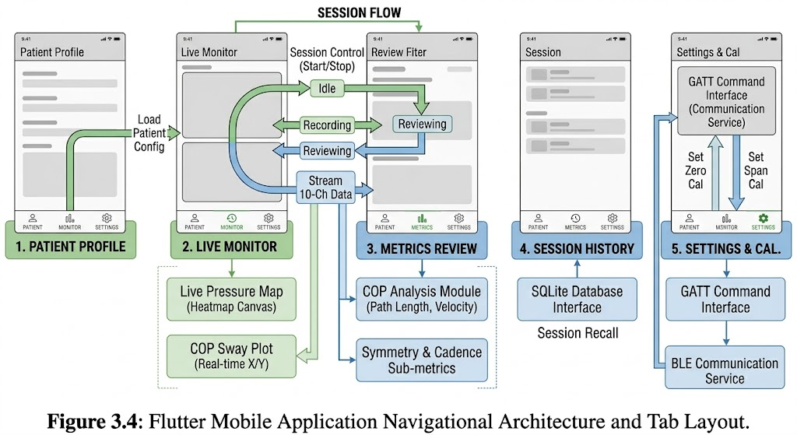 Figure 3.4 Flutter Mobile Applications Navigational Architecture and Tab Layout

3.5 Embedded Firmware Methodology
The embedded firmware running on each ESP32-S3 was designed to perform analog signal acquisition, filtering, calibration support, and BLE transmission. Each node continuously sampled the analog outputs of its five pressure sensors and prepared the data for real-time wireless communication.
- The major firmware tasks included;
- Initialization of the BLE service and characteristic
- Periodic analog sensor acquisition
- Signal smoothing and stabilization
- Zero and span calibration handling
- Scaling of sensor readings
- Packaging of sensor values into BLE data packets
- Repeated transmission to the mobile application.
Because the two insoles operated independently, the firmware was implemented separately on each ESP32-S3 module. The left and right foot devices were distinguished through separate BLE names and were both connected to the mobile applications simultaneously.
The firmware also supported calibration-oriented commands such as zero calibration and span calibration. Zero calibration was intended to set the unloaded baseline for a sensor or all sensors, while span calibration used a known applied weight to define a second calibration point. This two-point approach improved the practical usability of the pressure sensors during prototype testing.

3.6 Mobile Application Development
A Flutter-based mobile application was developed as the primary user interface for the smart insole system. The application was designed to receive BLE data streams from both the left and right insoles. Visualize the incoming sensor values and present gait-related indicators in a clinically interpretable manner. The project design direction explicitly included mobile application support and information for live and historical monitoring. The implemented application includes dedicated tabs for patient information, recording, cop review, clinical metrics, calibration, history, and settings.

The main functional components included:
- Display of left and right sensor values
- Center of pressure visualization for both feet
- Center of pressure trajectory display
- Live sensor graphic
- Recording control
- Calibration tools
- Session history clinical metrics
The application was also strong rehabilitation-oriented use loud subject information entry, a record session recording, a cop review tab, displayed recorded center of pressure trajectories, and a clinical metrics tab that summarized calculated parameters after recording.
The available interface components in the current application include connection status, live sensor values, balance panel recording controls, and the calibration page. Calibration of force-sensitive resistors is necessary because the FSR output is non-linear. Sensor-to-sensor variability and raw readings may drift or remain offset even when no load is applied. For this reason, the developed system incorporated a calibration process to improve the interpretability of the measured signals.
3.7 Calibration Methodology
The calibration methodology consisted of two major steps:
3.7.1 Zero Calibration
Zero Calibration was performed when no load was applied to the insole or to an individual sensor. The purpose of this step was to determine the unloaded baseline and reduce the offset that the system was designed to support, both one, global zero calibration for all sensors, and two, individual zero calibration for selected sensors. This step ensured that unloaded readings were brought close to zero before further measurements were taken.
3.7.2 Span Calibration
Span Calibration was based on applying a known reference weight to a particular sensor and using that value as the second calibration point. In this way, the relationship between the sensor output and applied load could be scaled more meaningfully than by zero calibration alone. The mobile application included fields for entering the known weight and buttons for sending per-sensor calibration commands. The overall calibration strategy, therefore, followed a two-point approach. One, unload zero references. Two, known weight span reference. Prototype development and improved inner-sensor consistency during testing.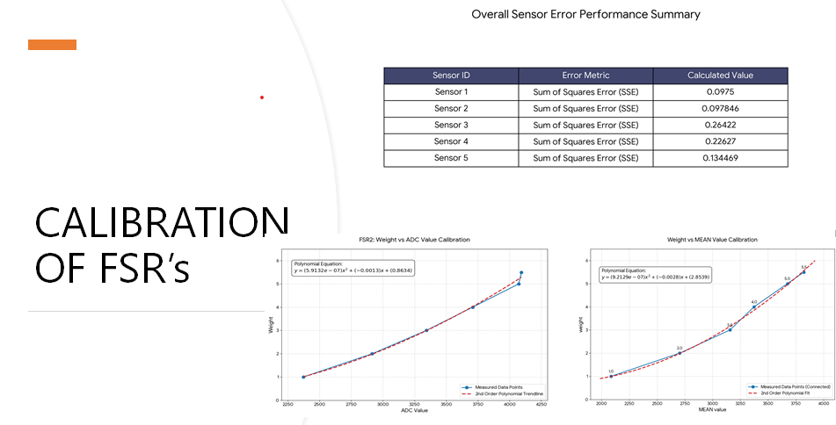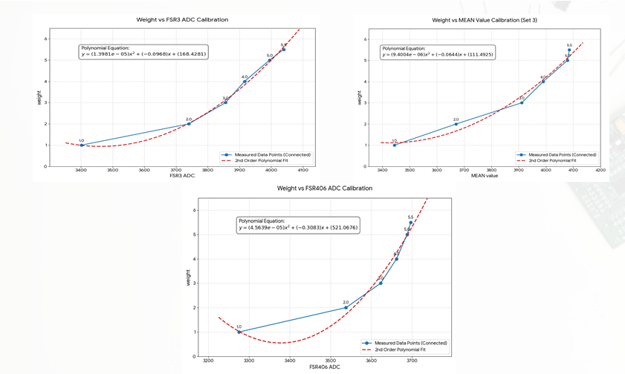
Figure3.7.2 Calibration of FSR's
3.8 Data Acquisition and Processing Workflow
The data acquisition process was continuous during system operation. Each ESP32-S3 acquired pressure signals from its five FSRs and transmitted the resulting values to the mobile application. The mobile application then updated the displayed values and computed higher-level parameters.
- The processing workflow can be summarized as follows:
- Acquire analog sensor values from the left and right insoles
- Apply filtering and calibration handling
- Transmit values via BLE
- Receive the values in the mobile application
- Compute foot-wise totals and bilateral comparisons
- Estimate COP using weighted sensor positions
- Determine gait-related state labels
- Estimate step count, cadence, and related metrics
- Record session data for later review.
This workflow enabled both live monitoring and offline review of recorded sessions.

3.9 Computation of Gait-Related Parameters
3.9.1 Foot-Wise Pressure Totals



3.9.2 Bilateral Balance

3.9.3 Symmetry Index

3.9.4 Center of Pressure
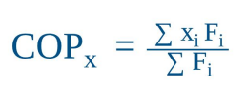

3.9.5 Step Count, Cadence, and Estimated Speed



3.10 Wearable Assembly and Testing Procedure
Insole electronics were assembled into a wearable configuration using ankle pouches attached through Velcro. This allowed the electronics battery charging module and microcontroller to be secured near the ankle while keeping the insole flexible and wearable. The prototype was then tested by wearing the system and observing real-time data in the mobile application.
The general testing procedure involved:
- Turning on both insole units
- Establishing a BLE connection with the mobile application
- Performing calibration with no load and known weights where required
- Wearing the insoles with ankle-mounted electronics
- Observing live pressure data during standing and walking
- Recording sessions through the application
- Reviewing COP and calculated gate indicators after recording
This methodology allowed the prototype to be evaluated as a complete wearable system, rather than as separate, isolated hardware modules.

3.11 Scope and Limitations of the Implemented Methodology
The methodology adopted in this work was intended for prototype development and proof of concept validation. The system successfully addressed low-cost bilateral pressure acquisition of BLE-based mobile monitoring and basic gait-related processing.
However, several limitations were made:
- The sensor configuration used 5 sensing nodes per foot rather than a dense pressure matrix, which limited spatial resolution.
- COP estimation was based on weighted sensor positions and therefore depended on simplified geometric assumptions.
- Estimated speed was not derived from an external ground truth distance measurement but from cadence and an assumed step length.
- Although the broader project concept referred to AI-powered smart insole functionality.
The implemented prototype in this thesis primarily focused on real-time pressure acquisition, visualization, calibration, and rule-based gait-related parameter estimation, rather than a fully trained machine learning model. The project presentation itself included an AI-oriented future direction and a clinician-facing interpretation. But the implemented core system centered on pressure sensing, BLE transmission, mobile application support, and gait-related indicators. These limitations do not reduce the value of the prototype as an engineering platform. Instead, they define clear directions for future work, including improved calibration. Denser pressure mapping, Physical coordinate COP refinement, validated gate speed measurement, and integration of machine learning models.

CHAPTER FOUR
4 IMPLEMENTATION AND RESULTS
4.1 Introduction
This chapter presents the implementation of the proposed Smart Insoles system and the prototype-level results obtained during functional testing. The purpose of this chapter is to demonstrate how the hardware and software components described in Chapter 3 were integrated into a working bilateral wearable system and to present the outputs generated by the machine. The implemented system was designed as a low-cost prototype for real-time gait monitoring and was evaluated primarily through hardware integration, communication testing, calibration, and live monitoring of gait-related parameters.
The project roadmap and presentation material also identified the major project stages as design, hardware/software integration, testing, analysis, and thesis completion. In this chapter, we will focus on practical implementation outcomes rather than formal clinical validation. Accordingly, this chapter discusses the completed hardware assembly, embedded firmware behavior, mobile application implementation, calibration workflow, and the observed performance of the prototype during preliminary standing and walking tests. Where appropriate, placeholders are indicated for figures and tables.
4.2 Hardware Implementation
4.2.1 Bilateral Smart Insole Prototype
The proposed system was implemented as two independent smart insoles, one for the left foot and one for the right foot. Each insole contained five force-sensitive resistors positioned at anatomically meaningful locations to capture major gait phases from heel strike to toe off. The project presentation identified the functional roles of the selected sensing regions, namely:
- Heel
- Medial region
- Midfoot
- Forefoot metatarsal region
- Toe
These placements were selected so that the prototype could capture initial contact, weight transfer, stability behavior, push-off loading, and terminal toe off. Each foot operated with its own ESP32S3 microcontroller, allowing bilateral acquisition without long interfoot wiring. The electronics were powered using a 3.7 V Li-po battery and TP4056 charging module, with an on/off switch provided for user control.
The sensing node and power module were attached using an ankle pouch fixed with velcro during testing. This wearable configuration allowed the electronics to remain outside the planar contact region while maintaining portability and ease of wear, as described in the project methodology and user implementation details. Figure 4.1, final hardware prototype of left and right smart insoles with electronics assembly.
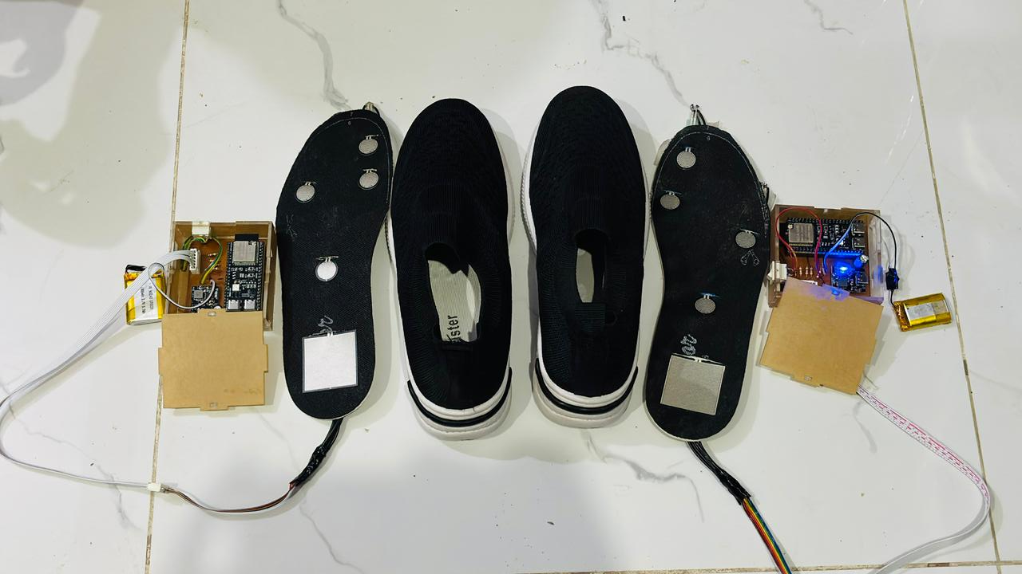
Figure 4. 1 Final hardware prototype of left and right smart insoles with electronics assembly
4.2.2 Sensor Interfacing Circuit
Each insole used four FSR-402 sensors and one FSR-406 sensor. The sensors were interfaced through a resistor-based voltage divider arrangement. The FSR-402 elements were connected through 3.3 kΩ resistors, while the FSR-406 was connected through a 150 Ω resistor. This circuit configuration was designed to convert resistance changes due to plantar pressure into analog voltage variations measurable by the ESP32-S3 ADC inputs. The implemented circuit aimed to preserve a practical balance between sensitivity, signal variation, simplicity, and low-cost fabrication.
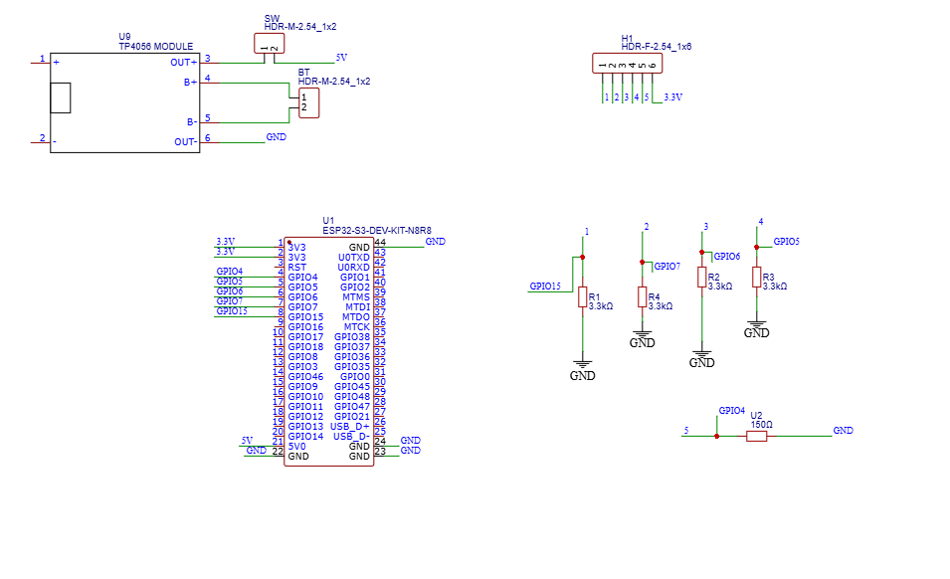
Figure 4. 2 Circuit schematic of one insole sensing channel arrangement

4.2.3 Wearable Assembly
The final prototype was assembled in a wearable form that allowed the insole sensors to remain embedded within the shoe or test insole while the electronics were mounted externally near the ankle. This configuration reduced discomfort and protected the microcontroller, battery, and charging module during use.
Practical testing confirmed that the system could be worn and operated without tethering to an external computer, which was an essential requirement for real-time mobile gait monitoring. Figure 4: The developed wearable smart insole hardware assemblies prior to final footwear integration.

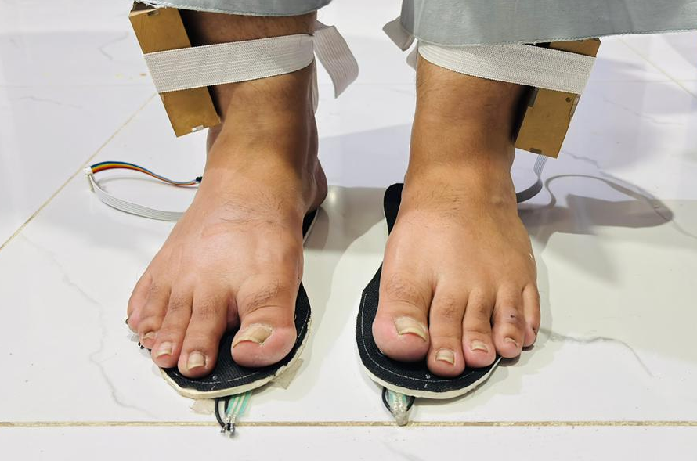
Figure 4. 3 Developed wearable smart insole hardware assembly prior to final footwear integration.

4.3 Embedded System Implementation
4.3.1 ESP32-S3 Firmware
The embedded firmware was developed to perform sensor acquisition, signal conditioning, calibration handling, and BLE data transmission. Each ESP32S3 node continuously sampled the 5 sensor channels of its corresponding insole and prepared the sensor outputs for wireless transmission.
The project implementation evolved from an initial baseline offset model toward a more structured calibration-capable system supporting both zero calibration and per-sensor span calibration. The firmware was configured so that each foot advertised itself with BLE as a separate device. This allowed the mobile application to identify and connect to the left and right insoles independently. The firmware supported livestreaming of sensor packets and responded to calibration-related commands sent from the mobile application.

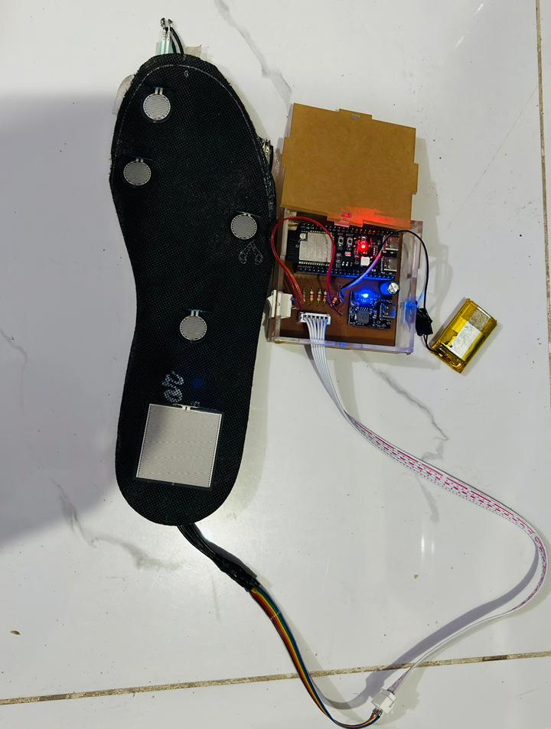
Figure 4. 4 Physical wired implementation of the single insole node hardware showcasing the ESP32-S3 microcontroller, interfacing resistor network, and power management module.
4.3.2 Calibration Support in Firmware
The final firmware supported the following calibration operations:
- Global zero calibration for all sensors, per-foot zero calibration, per sensor zero calibration, per-sensor span calibration using a known weight, and calibration clearing reset. This calibration support was essential because the raw force-sensitive resistor outputs were affected by baseline offset, inter-sensor variation, and non-linear behavior.
- The introduction of zero and span calibration proved the practical stability of the readings and made the live values more suitable for comparative plantar pressure interpretation during testing
4.3.3 BLE Data Transmission
The firmware transmitted sensor values through a BLE service and characteristic shared across the insole nodes. The project implementation used a BLE communication workflow in which ESP32 devices sent real-time data to the mobile application simultaneously. The project presentation also explicitly states that both ESP32 modules were connected to the mobile application through Bluetooth and that the intended system performs continuous bilateral plantar pressure monitoring. The BLE implementation was designed to support real-time use rather than offline dumping of sensor data, thereby enabling live visualization and session recording inside the mobile application.
4.4 Mobile Application Implementation
4.4.1 Application Architecture
A Flutter-based mobile application was developed as the main interface for the smart insole system. The application implemented a clinical workflow-style structure and included support for multiple operational tabs. Based on the implemented application code, the primary tabs included: Patient, Record, COP Review, and Clinical Metrics. In addition, the outer application navigation also included History, Calibration, and Settings. This structure allowed the prototype to move beyond simple live sensor display and toward a more organized data acquisition and review workflow.
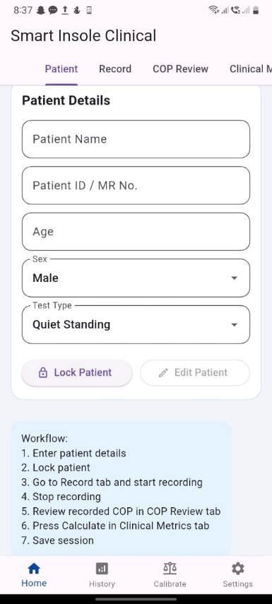
Figure 4. 5 Mobile application initialization interface displaying the patient demographic profile registration panel.
4.4.2 Real-Time Monitoring Interface
The record tab was used for live monitoring and incorporated the following functional components: patient summary information, connection status for both insults, recording control buttons, live left and right sensor values, bilateral pressure map, live cop trajectory, left/right balance comparison, live sensor graph display, and a feature summary panel. These features are visible in the current application implementation and were designed to provide an integrated real-time picture of plantar pressure behavior during standing and walking. Figure 4.6: Main Real-time Monitoring and Recording Interface dashboard showing Independent Bilateral Insole Connection Telemetry Status Blocks
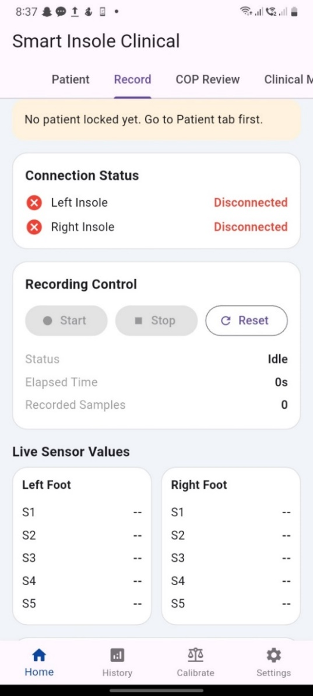
Figure 4. 6 Main real-time monitoring and recording interface dashboard showing independent bilateral insole connection telemetry status blocks.
4.4.3 Pressure Map Visualization
The application displayed left and right foot pressure maps using a graphical foot template with color-coded sensor markers. The code implements separate left and right foot panels in which each sensor is placed at a defined relative location and colored according to its live value. Low values appear near the green range, and higher values move through yellow and orange toward red. This feature provides immediate visual feedback regarding plantar loading distribution and allows users to observe whether the foot is heel-dominant, toe-dominant, or bilaterally imbalanced.
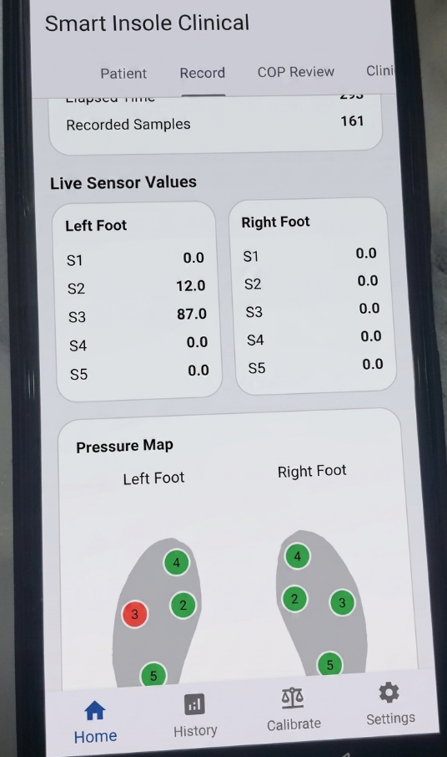
Figure 4. 7 Pressure map screen showing left and right foot sensor values
4.4.4 COP Trajectory Visualization
The mobile application implemented a dedicated COP visualization section using weighted sensor positions and a custom painter. The COP trajectory was displayed both during live monitoring and in a dedicated COP review tab for recorded sessions. The current implementation also computes derived COP measures such as path length, medial-lateral sway, and anterior-posterior sway. This feature is important because COP movement reflects dynamic weight transfer behavior and can indicate postural stability or gait transition trends.
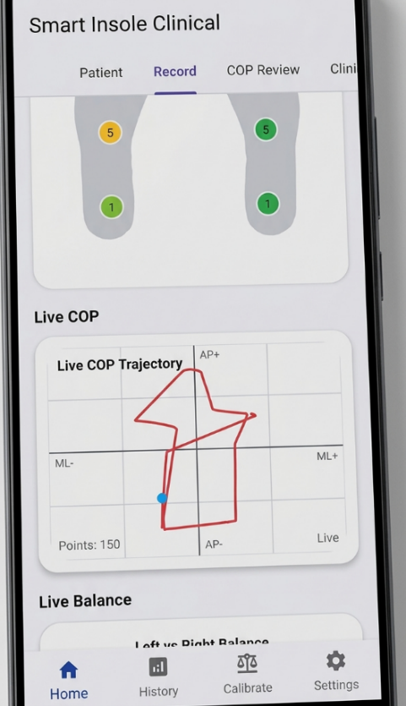
Figure 4. 8 Center of Pressure (COP) trajectory plotting graph capturing real-time postural sway coordinates during active tracking.
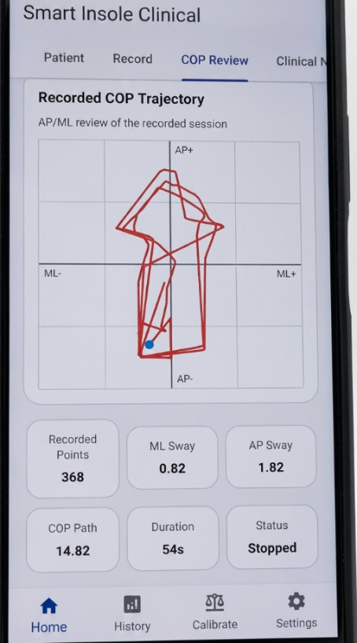
Figure 4. 9 Post-session review screen displaying calculated spatiotemporal metrics and the complete compiled Center of Pressure (COP) trajectory path.
4.4.5 Clinical Metrics and Session Recording
The application supported a simple recording workflow in which a patient could be registered, a session could be started and stopped, and clinical metrics could be calculated after recording. The metrics tab was designed to summarize duration, steps, cadence, speed, mean left/right totals, bilateral balance, symmetry, COP path, ML sway, AP sway, mean COP velocity, and RMS-based sway values. The application also included a history of storage through a local storage service, enabling previously recorded sessions to be saved and reviewed later.
It is important to note, however, that the implemented speed remains at an estimated speed based on cadence and assumed step length rather than a clinically validated true gait speed. Likewise, COP sway values are dependent on the current sensor coordinate model and therefore represent prototype-level quantitative indicators.
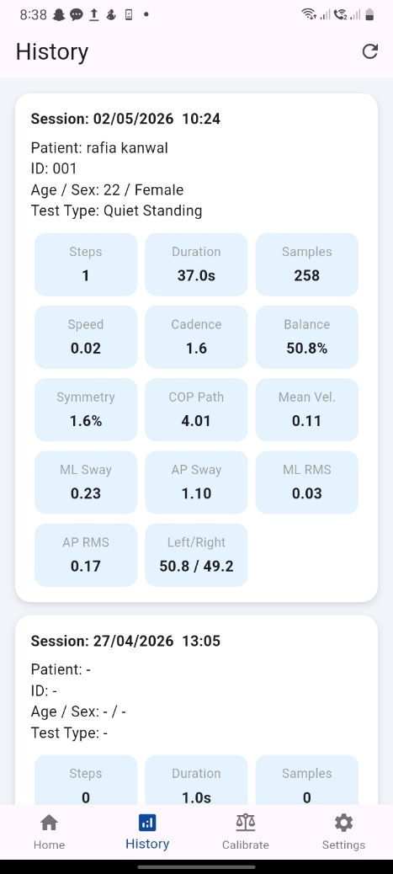
Figure 4. 10 Post-session review screen of the mobile application displaying computed spatiotemporal clinical metrics and gait symmetry indices.
4.5 Calibration Implementation and Results
4.5.1 Calibration Page
A dedicated calibration page was implemented to support practical sensor calibration through the mobile application. The final calibration interface included: a global zero-all control, per-foot zero-all controls, per-foot clear calibration controls, and per-sensor controls for zero and span calibration. Each sensor row displayed the live sensor value, a known-weight entry field, and buttons for Zero and Span calibration. This allowed the calibration workflow to move from a simple global reset toward a more structured two-point method. The implemented calibration interface also displayed connection and streaming status for each foot so that calibration actions could be applied only to connected devices. This functionality followed directly from the updated app logic and BLE command architecture.
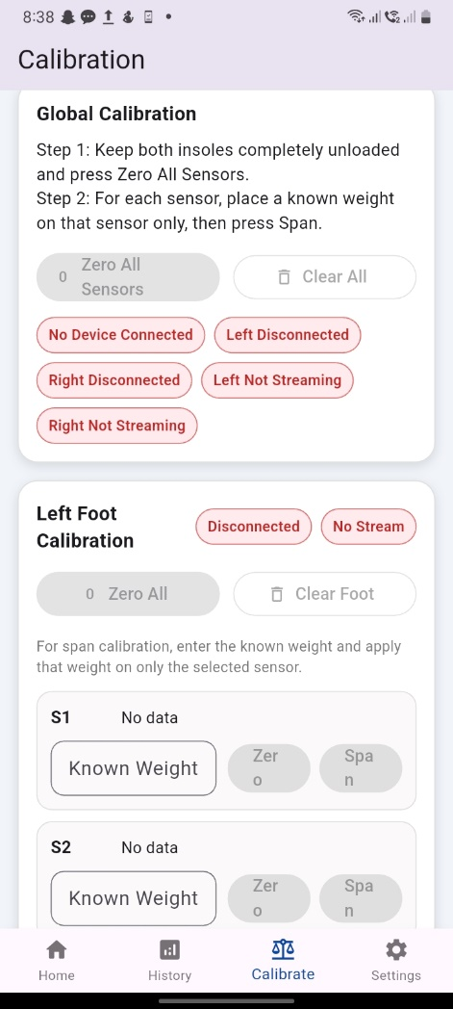
Figure 4. 11 Calibration page with global and per-sensor controls
4.5.2 Zero Calibration Behavior
Zero calibration was intended to bring no load sensor values closer to zero. During testing, when an insole was left unloaded, and a zero calibration command was issued, the corresponding live sensor values decreased substantially compared with precalibration-driven conditions. This improved the stability of the pressure pad and reduced false pressure indications during no-contact conditions.
4.5.3 Span Calibration Behavior
Span calibration was implemented by entering a known weight and applying it to the selected sensor. The app then sent a BLE command to the corresponding ESP32 node so that the firmware could store the sensor's loaded reference. This improved the interpretability of the live sensor values and provided a more practical basis for comparing pressure variation between sensors.
As discussed during implementation, the calibration system treated the entered value as a consistent arbitrary or physical unit, and the use of grams was recommended for practical consistency across all sensors. Although the prototype demonstrated functional calibration support, the calibration process remains sensitive to proper load placement. Because FSR loading can spread to adjacent regions, span calibration accuracy depends on placing the known weight as directly as possible on the intended sensor.
4.5.4 Calibration Summary
The implemented calibration workflows successfully achieved the following: No-Load Zero correction per sensor adjustment capability, Known Weight Reference Support, and Mobile Controlled Calibration without requiring re-programming 30-32 units. This was an important implementation result because it transformed the prototype from a raw sensor display system into a practically tunable wearable gate monitor and platform.

Sensor | Before Zero Calibration (ADC Counts) | After Zero Calibration (ADC Counts)
Left S1 | 142 | 0
Left S2 | 98 | 0
Left S3 | 115 | 0
Left S4 | 87 | 0
Left S5 | 131 | 0
Right S1 | 122 | 0
Right S2 | 104 | 0
Right S3 | 91 | 0
Right S4 | 118 | 0
Right S5 | 135 | 0
Table 4. 1: Example no-load sensor values before and after zero calibration
4.6 Preliminary Functional Testing
4.6.1 Connection and Streaming Verification
Functional testing first verified that both insults could be discovered independently and connected through BLE to the mobile application. The connection status panel of the application was used to confirm whether the left and right devices were connected and whether they were actively streaming. During testing, successful BLE pairing and bilateral packet reception confirmed that the independent dual-node architecture was operational.
4.6.2 Live Pressure Response
The system was then tested by applying pressure manually and by wearing smart inserts. Sensor values changed in real time in response to pressure application, and the pressure map reflected the location and relative magnitude of the applied load. The visual behavior of the left and right foot maps confirmed that the system could differentiate foot-wise loading and respond dynamically as weight was shifted.
4.6.3 Bilateral Balance Behavior
The balance visualization panel displayed the relative percentage of loading on the left and right feet. During practical testing, when body weight was shifted laterally, the balance indicator changed accordingly, demonstrating that the bilateral pressure totals responded to asymmetrical loading. This validated the basic functioning of the bilateral architecture and the corresponding software interpretation.
4.6.4 COP Response
Live COP plotting was tested by applying variable pressure and shifting body weight across the feet. The COP trajectory changed as expected to weight transfer, confirming that the weighted position model was functioning at the application level. However, at this stage, the COP output should be interpreted as a prototype-level estimate because it depends on the assumed sensor coordinate model rather than on fully validated anatomical coordinates.
4.6.5 Gait-Related Parameter Behavior
The application implemented rule-based estimation of gate-related parameters such as gait phase labels, step count, cadence, and estimated speed. Based on current logic, the system differentiated events such as no contact, double support, left/right stance, left/right heel strike, and left/right toe off. The implemented gait logic used pressure threshold and heel/toe dominance relations derived from bilateral live sensor values. The code also computes balance, symmetry, step count, cadence, COP path, and sway-related indicators. Preliminary functional testing indicated that the system could generate gait-related state transitions during walking and standing.
However, these values should currently be treated as prototype indicators rather than formally validated clinical outputs.

Test Condition | Expected Outcome | Observed Outcome
No load on both insoles | Sensor values near zero after calibration | Bilateral sensor outputs stabilized at 0 ADC counts; the application baseline displayed a completely idle state.
Weight shift to the left | Left balance increases | Left side balance percentage shifted to 75–85%; left pressure map silhouettes highlighted a high-intensity load.
Weight shift to the right | The right balance increases | Right side balance percentage shifted to 80–90%; right pressure map silhouettes updated immediately to maximum intensity.
Heel-dominant loading | Heel sensors respond more strongly | High-magnitude pressure response localized at the calcaneus region sensors; COP trajectory point shifted downwards along the AP axis.
Toe-dominant loading | Toe/forefoot sensors respond more strongly | Primary pressure activity was detected across the metatarsal and hallux sensor channels; COP trajectory coordinates migrated upwards along the AP axis.
Slow walking | Step count increments and gait label changes | Step counter incremented reliably with each complete gait cycle; live status dashboard updated dynamically during active locomotion.
Table 4. 2:Prototype functional testing observations
4.7 Discussion of Prototype Performance

The implemented Smart Insole system successfully achieved the primary prototype objectives of bilateral pressure acquisition, BLE-based communication, mobile visualization, calibration support, and generation of gait-related monitoring outputs. The hardware remained portable and wearable.

The communication architecture functioned in real time, and the app provided a structured clinical style interface for monitoring and recording. A major strength of the prototype is its low cost and modular architecture. By using five strategically placed sensors per foot instead of a dense pressure array, the system remained easy for embedded bilateral monitoring.

The use of independent ESP32 S3 nodes also simplified foot-wise acquisition and allowed the app to represent left and right foot data simultaneously. At the same time, the current results should be interpreted in the context of prototype limitations. The pressure-sensing approach does not provide the spatial resolution of commercial pressure platforms. COP computation is still based on simplified sensor position assumptions. The estimated speed is not derived from ground truth walking distance or motion capture. Although the broader project concept discussed AI-powered smart insights and clinician support, the current implemented system is primarily a real-time sensing visualization and rule-based monitoring platform rather than a fully trained machine learning diagnostic system.

The project slides also show that AI-based gait intelligence and clinician-oriented insight generation were part of the broader vision, while the implemented system in code currently emphasizes live monitoring, COP review, calibration, and clinical metrics computation. These observations do not reduce the significance of the present work. Instead, they show that the project has produced a functional engineering prototype that can serve as a foundation for future quantitative validation and intelligent analysis.

4.8 Summary

This chapter presented the implementation and prototype-level results of the developed Smart Insole System. The final system consisted of bilateral sensitized insoles, independent ESP32 S3-based wearable nodes, BLE communication, a mobile application for live and recorded monitoring, and a calibration workflow based on zero and span adjustment. The prototype successfully demonstrated real-time plantar pressure acquisition, bilateral balance visualization, pressure map display, trajectory generation, session recording, and calculation of basic gait-related indicators.

Functional testing confirmed that the developed system responds to live loading changes and supports wearable use. Although the current system remains a prototype and its quantitative outputs require further validation, the implementation results show that the proposed architecture is feasible and suitable for low-cost real-time gate monitoring. The next chapter presents the discussion, conclusion, limitations, and recommendations for future

CHAPTER FIVE

5 DISCUSSION AND CONCLUSION

5.1 Further Opportunities
While the developed AI-powered Smart Insole system successfully fulfills its foundational design milestones, several technical, material, and analytical opportunities exist to scale this prototype into a highly robust, clinically certified biomedical platform. A significant opportunity lies in embedding the 6-axis inertial measurement unit alongside the ESP32-S3 microcontroller on the ankle-mounted node. Fusing spatial plantar pressure data with temporal acceleration and angular velocity kinematics will allow the system to calculate critical advanced metrics such as:
- Stride length
- Swing velocity
- Heel strike angles
- Active fall risk predictive indices
For machine learning classification, the processing capabilities of the mobile application and cloud environment can be extended by deploying machine learning algorithms such as support vector machines, random forests, or artificial neural networks. This will enable the system to transition from basic parameter streaming to automated real-time diagnostic classification capable of identifying abnormal gait pathologies, tracking rehabilitation progress over time, or alerting users to diabetic foot ulcer risk.
Hardware, material, and thin film optimization: future iterations can replace the standard PISA resistive FSR sensors with advanced flexible printed circuits (FPCs), capacitive textile-based pressure matrices, or self-powered triboelectric nanogenerators. These material upgrades will dramatically reduce overall insole thickness, minimize inherent sensor hysteresis, and improve long-term mechanical durability against continuous structural cyclic load.
Clinical trials and structural validation studies: expanding the testing protocol to include large-scale clinical validation studies will strengthen the system's reliability. Cross-referencing the insole's data streams against gold standard clinical systems, such as laboratory-grade force plates and optical motion capture systems, will establish high diagnostic confidence for physical therapists and rehabilitation clinicians
5.2 Conclusion
This thesis successfully demonstrates the complete design, implementation, and functional validation of an independent bilateral wearable smart insole system engineered for real-time gait monitoring. By optimizing a biomechanically targeted layout of five force-sensitive resistors (four FSR402 and one FSR406) mapped to key anatomical loading zones, the system effectively captures critical phase transitions during human ambulation without the cost or complexity of high-density matrix arrays. The dual ESP32-S3 hardware architecture operates autonomously on each foot, successfully eliminating restrictive crossover wires and preserving the user's natural mobility through custom-developed firmware and low-latency Bluetooth Low Energy communication. Localized pressure data is continuously streamed and processed. The flutter-based mobile application successfully displays these inputs, providing immediate visual biofeedback across essential parameters, including:
- Active pressure distribution
- Left-right symmetry
- Real-time center of pressure
- Top P trajectories
- Dynamic step counts
Ultimately, this project accomplishes its core objectives by providing a highly affordable, accessible, and practical alternative to lab-bound gait assessment environments. By bridging embedded systems engineering with mobile health applications, this work establishes a scalable framework for remote patient tracking and digital rehabilitation tools.

CHAPTER SIX
6 REFERENCES
[1] Q. Wang et al., “A wireless, self-powered smart insole for gait monitoring and recognition via nonlinear synergistic pressure sensing,” 2025.
[2] A. G. Samarentsis, G. Makris, S. Spinthaki, G. Christodoulakis, M. Tsiknakis, and A. K. Pantazis, “A 3D-Printed Capacitive Smart Insole for Plantar Pressure Monitoring,” Sensors (Basel), vol. 22, no. 24, p. 9725, Dec. 2022, doi: 10.3390/S22249725.
[3] A. Khandakar et al., “Design and Implementation of a Smart Insole System to Measure Plantar Pressure and Temperature,” Sensors, vol. 22, no. 19, Oct. 2022, doi: 10.3390/s22197599.
[4] X. Yin et al., “High-resolution pressure sensing insole via sensitivity-tunable fibers towards gait recognition,” Chemical Engineering Journal, vol. 505, p. 159841, Feb. 2025, doi: 10.1016/J.CEJ.2025.159841.
[5] A. M. Tan, F. K. Fuss, Y. Weizman, Y. Woudstra, and O. Troynikov, “Design of Low Cost Smart Insole for Real Time Measurement of Plantar Pressure,” Procedia Technology, vol. 20, pp. 117–122, 2015, doi: 10.1016/J.PROTCY.2015.07.020.
[6] M. Alegria, M. Ballesteros, and D. Cruz-Ortiz, “A wireless instrumented insole for monitoring plantar pressure during human locomotion,” Sens. Biosensing Res., vol. 47, p. 100752, Feb. 2025, doi: 10.1016/J.SBSR.2025.100752.
[7] P. Castro-Martins, A. Marques, L. Pinto-Coelho, P. Fonseca, and M. Vaz, “A Portable Insole System for Actively Controlled Offloading of Plantar Pressure for Diabetic Foot Care,” Sensors (Basel), vol. 25, no. 12, p. 3820, Jun. 2025, doi: 10.3390/S25123820.
[8] R. de Fazio, E. Perrone, R. Velázquez, M. De Vittorio, and P. Visconti, “Development of a self-powered piezo-resistive smart insole equipped with low-power ble connectivity for remote gait monitoring,” Sensors, vol. 21, no. 13, Jul. 2021, doi: 10.3390/s21134539.
[9] T. Cudejko, K. Button, and M. Al-Amri, “Wireless pressure insoles for measuring ground reaction forces and trajectories of the centre of pressure during functional activities,” Sci. Rep., vol. 13, no. 1, Dec. 2023, doi: 10.1038/s41598-023-41622-3.
[10] Q. Zheng et al., “Self‐powered high‐resolution smart insole system for plantar pressure mapping,” BMEMat, vol. 1, no. 1, Mar. 2023, doi: 10.1002/bmm2.12008.
[11] P. X. Fuchs, W. H. Chen, and T. Y. Shiang, “Center of Pressure Measurement Accuracy via Insoles with a Reduced Pressure Sensor Number during Gaits,” Sensors, vol. 24, no. 15, Aug. 2024, doi: 10.3390/s24154918.
[12] R. A. Brindle, C. M. Bleakley, J. B. Taylor, R. M. Queen, and K. R. Ford, “Validity of estimating center of pressure during walking and running with plantar load from a three-sensor wireless insole,” Wearable Technologies, vol. 3, p. e8, Jun. 2022, doi: 10.1017/WTC.2022.5.
[13] Y. Tian et al., “Deep-learning enabled smart insole system aiming for multifunctional foot-healthcare applications,” Exploration, vol. 4, no. 1, Feb. 2024, doi: 10.1002/EXP.20230109.
[14] J. G. Ho, Y. Kim, and S. D. Min, “Customized Textile Capacitive Insole Sensor for Center of Pressure Analysis,” Sensors, vol. 22, no. 23, Dec. 2022, doi: 10.3390/s22239390.
[15] B. Ren and J. Liu, “Design of a plantar pressure insole measuring system based on modular photoelectric pressure sensor unit,” Sensors, vol. 21, no. 11, Jun. 2021, doi: 10.3390/s21113780.
[16] S. R. Crossland, H. J. Siddle, C. L. Brockett, and P. Culmer, “Evaluating the use of a novel low-cost measurement insole to characterise plantar foot strain during gait loading regimes,” Front. Bioeng. Biotechnol., vol. 11, 2023, doi: 10.3389/fbioe.2023.1187710.
[17] D. K. Agrawal et al., “Smart Insole-Based Plantar Pressure Analysis for Healthy and Diabetic Feet Classification: Statistical vs. Machine Learning Approaches,” Technologies 2024, Vol. 12, Page 231, vol. 12, no. 11, p. 231, Nov. 2024, doi: 10.3390/TECHNOLOGIES12110231.
[18] C. A. Abbott et al., “Innovative intelligent insole system reduces diabetic foot ulcer recurrence at plantar sites: a prospective, randomised, proof-of-concept study,” Lancet Digit. Health, vol. 1, no. 6, pp. e308–e318, Oct. 2019, doi: 10.1016/S2589-7500(19)30128-1.
[19] J. M. Park et al., “Detection of freezing of gait in Parkinson’s disease from foot-pressure sensing insoles using a temporal convolutional neural network,” Front. Aging Neurosci., vol. 16, 2024, doi: 10.3389/fnagi.2024.1437707.
[20] D. Bose, G. Singh, S. Gupta, and A. Chanda, “Development of a Novel Customized Insole for Effective Pressure Offloading in Diabetic Patients,” Prosthesis, vol. 6, no. 2, pp. 341–356, Apr. 2024, doi: 10.3390/prosthesis6020026.
[21] P. Castro-Martins, A. Marques, L. Coelho, M. Vaz, and J. S. Baptista, “In-shoe plantar pressure measurement technologies for the diabetic foot: A systematic review,” Heliyon, vol. 10, no. 9, p. e29672, May 2024, doi: 10.1016/J.HELIYON.2024.E29672.
[22] I. M. Prasetyanto, R. A. M. Andriana, I. P. A. Pawana, D. Tinduh, H. Novida, and B. Utomo, “Insoles reduce peak plantar pressure in diabetic peripheral neuropathy,” Journal of Medicinal and Pharmaceutical Chemistry Research, vol. 6, no. 5, pp. 571–580, May 2024, doi: 10.48309/JMPCR.2024.432908.1072.
[23] D. K. Agrawal et al., “Smart Insole-Based Plantar Pressure Analysis for Healthy and Diabetic Feet Classification: Statistical vs. Machine Learning Approaches,” Technologies (Basel)., vol. 12, no. 11, Nov. 2024, doi: 10.3390/technologies12110231.
[24] M. Nouman, T. Dissaneewate, W. Leelasamran, and S. Chatpun, “The insole materials influence the plantar pressure distributions in diabetic foot with neuropathy during different walking activities,” Gait Posture, vol. 74, pp. 154–161, Oct. 2019, doi: 10.1016/J.GAITPOST.2019.08.023.
[25] P. Seth, V. Gadi, and G. Premalatha, “Smart Insole Gait Analysis,” 4th IEEE International Conference on Distributed Computing and Electrical Circuits and Electronics, ICDCECE 2025, 2025, doi: 10.1109/ICDCECE65353.2025.11035378.
[26] L. A. Cramer, M. A. Wimmer, P. Malloy, J. A. O’keefe, C. B. Knowlton, and C. Ferrigno, “Validity and Reliability of the Insole3 Instrumented Shoe Insole for Ground Reaction Force Measurement during Walking and Running,” Sensors, vol. 22, no. 6, Mar. 2022, doi: 10.3390/s22062203.
[27] G. T. Ramadhan et al., “Effect of different inner pressures of air insoles and walking durations on plantar pressure time integral,” Scientific Reports 2024 14:1, vol. 14, no. 1, pp. 19272-, Aug. 2024, doi: 10.1038/s41598-024-70312-x.

